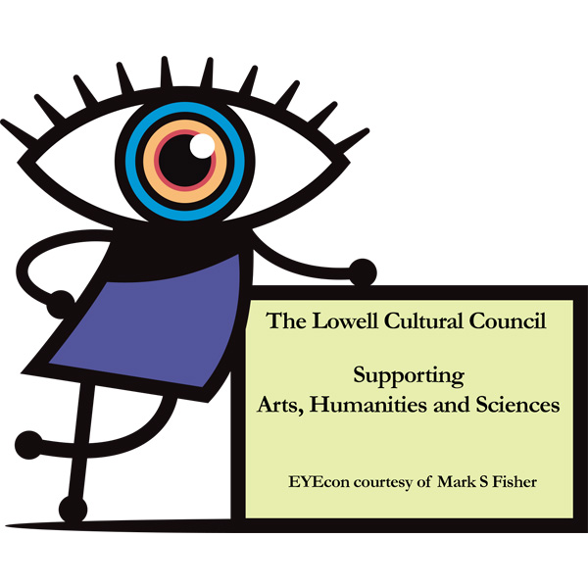
FOR IMMEDIATE RELEASE | Contact: Marta Magnus, LHS  mmagnus@lowell.k12.ma.us  Julia D’Angelo, Murkland School
 | jdangelo@lowell.k12.ma.us

Visual Voices VIII
A biennial city-wide art show featuring work by Lowell’s K-12 students artists.

Lowell, MA February 26, 2018 Visual Voices VIII celebrates Lowell’s K-12 student artists with exhibits at The Brush Gallery, Lowell Telecommunications Corps and The Whistler House Museum of Art.

Elementary School artwork at The Brush Art Gallery and Studios, 256 Market Street Lowell, MA
Artwork will be on display: 3/31-4/29
Reception Time on April 7th: 1-3pm. Award ceremony begins at 1:30 pm.
Please access www.thebrush.org/directions for directions and hours.

Middle School artwork at Lowell Telecommunications Corp. Gallery, 246 Market St. Lowell, MA.
Artwork will be on display: 4/1-4/27
Reception Time on April 7th: 12-2. Award ceremony begins at 1 pm.
Please access www.ltc.org/facility_and_hours for directions and hours.

High School artwork at The Whistler House Museum of Art, 243 Worthen St. Lowell, MA.
Artwork will be on display: 3/1-4/7
Reception Time on April 7th: 2-4pm. Award ceremony begins at 3pm.
Please access www.whistlerhouse.org for directions and hours.

Visual Voices, started in 2002 by art teacher and local artist Lolita Demers, has grown into a biennial city-wide art event thanks to the collaborative efforts of local galleries, art teachers and the incredible student artists.

Thank you to the Lowell Public Schools, the Lowell Cultural Council and the Massachusetts Cultural Council for their continued support of the student artists in Lowell.

Visual Voices is organized by a dedicated group of art teachers including Julia D’Angelo, Murkland School, Lolita Demers, Morey School, Chrissy Dixon, McAuliffe School, Marta Magnus, Lowell High School, Erin Noonan, Lincoln School, Denise Piekos, Bartlett School, and Dr. Sharon Clark, Fine Arts Department Chair, LHS.

